A proposal of the standard of pricing in accommodations

# Background

With the appearance of Airbnb, TripAdvisor and so on, the applications which help customers finding short-term accommodations are becoming more and more popular. As the big differences among various accommodations, the pricing basely depends on the experiences and subjective opinions. Thus, pricing will spend much time on comparing others’ prices to determine the individual price and the final price may not appropriate. Meanwhile, the similar problem plagues the seekers, because they need to scan a mass of information to make a sense of the price with a certain condition. It is possible that he or she may find a record with a suitable price but the bad condition, because of the wrong pricing. Even, some people or organizations may take advantage of this drawback to control the market quotation for one’s own interest. This paper indicates the brief contents of this proposal.

Submitted by

Yudi Chen 13020363

Table of Contents

Background 1

1. Aim & Objects 3

2. Research project 3

3. Time estimation 4

4. Budget 5

5. Personnel 5

# Aim & Objects

The final aim: deploying this business at the areas which have relevant businesses

Objects:

Phase I

1. Knowing the number of businesses which need to add this business and their contents
2. Assigning personnel
3. Allocating work
4. Selecting the test business as the flagship
5. Determining the recourses
6. Purchasing equipment
7. Preparing hardware environment(datacenter and topology of networks)
8. Documenting the implementation plan
9. Preparing infrastructure for next phase

Phase II,III and IV

1. Initiating the project

Phase V

1. Checking and accepting the project
2. Expanding to other businesses
3. Recycling recourses

# Research project

After finishing this project, the biggest benefits of the investor are saving cost and time and improving efficiency of processing services. Firstly, this business is not a traditional machine which executes the commands rigidly but an intelligent ‘person’. The process of building the standard is like absorbing the sufficient experience from predecessors who do this job and processing a bigger amount of information than them. Due to this way is more efficient, correctly and faster than people, more time can be saved, meanwhile, the reduction of staff can save salary directly along with the reduction of spending on personnel management. Secondly, a recommended range of pricing can simplify the process of posting and reduce the confuse of those who are posting a piece of message if the price is reasonable, followed by the increase of customers’ satisfactions. Basically, from the perspective of technology(phase II, III and IV), this project consists of:

Phase II, III and IV

1. Capturing the business data from the databases and restoring the data as the test environment after data processing
2. Training the dataset using various classifiers to build models
3. Selecting the most suitable one through evaluating the models
4. Implementing the business on real time by programming
5. Troubleshooting the existing problems until running well on the test environment

Phase III

1. Migrating this project to production environment
2. Troubleshooting the possible problems on production environment
3. Maintaining the system until becoming stable

Phase IV

1. Documenting the operation manual including methods of addressing issues for expanding

# Time estimation

The Gantt chart of the whole project is shown as Figure 3.1 and Figure 3.2. Because the project contains the expansion to other businesses, the project cycle depends on the number of businesses, although the implementation on one business can be estimated. Therefore, the part of expansion(5.3 in both figures) only spends one day.

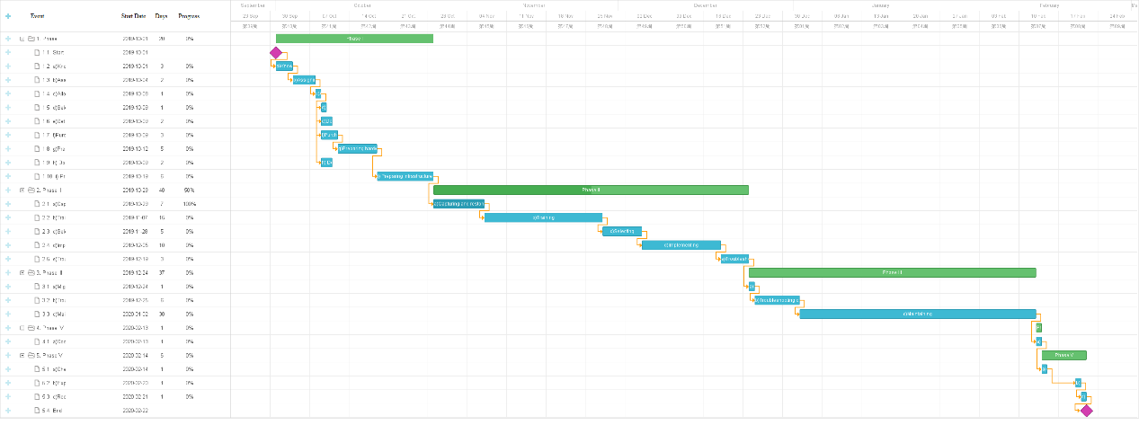

Figure 3.1 a Gantt chart of the project

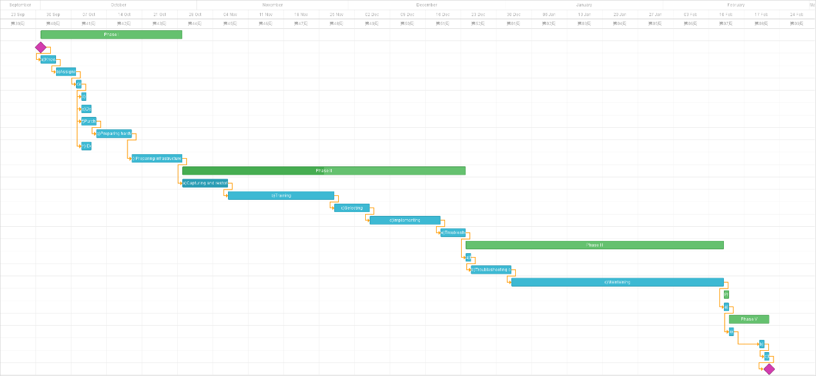

Figure 3.2 the detailed phases

# Budget

The total cost of flagship is shown as the Table 4.3. As the increased number of the expansion, although the value must change, the final cost can still be estimated. The final value is around *n*\*310,000(n is the number of expansion).

|  |  |
| --- | --- |
| **Component** | **$A(millions)** |
| Software implementation | 70,000 |
| Hardware, network infrastructure and security components(RFP, purchase & implementation) | 100,000 |
| Costs of staff in the project | 90,000 |
| Contingency | 50,000 |
| ***Total*** | 310,000 |

Table 4.1 The detailed budget in flagship

# Personnel

As the project starts, the personnel change will happen. One project manager is the necessity and the 2 HRs are required to coordinate staff recourses. The demand of technical personnel, however, depends on the way of project implementation. If the enterprise has enough technical personnel who do not have necessary work to do, the technical personnel are from the enterprise self. However, another option is outsourcing the project, the cost on technical personnel transfers to the outsource.

On the other hand, as the project finish, some positions association with relevant business can be remove so that the enterprise can decline these recourses, such as the salary, offices and HR, forever.

In summary, the personnel are listed below:

Add:

Project management * 1

HR * 2

Technical staff * 3 (developer * 1, background * 2, security * 1)

Remove:

Business personnel * n( is based on the original numbers)

**Video Link:** [**https://www.youtube.com/watch?v=lVPby9E6De8&feature=youtu.be**](https://www.youtube.com/watch?v=lVPby9E6De8&feature=youtu.be)